UNIT 5
Lesson 7 – WHERE AM I

- 1 Tia and Ollie  are playing a guessing game.
Tia i Ollie igraju igru pogađanja.

a) Ollie is asking Tia questions.
Listen to your teacher read the text.
Ollie postavlja Tiji pitanja kako bi saznao gdje je ona.
Poslušaj svog učitelja kako čita tekst.

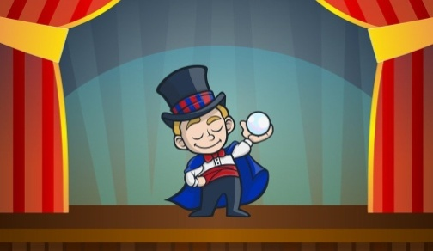
Ollie: Are you watching a play?
Gledaš li kazališnu predstavu?
Tia: No, I am not.
Ne, ne gledam.


Ollie: Are you watching a film? ?
Gledaš li film?

Tia: No, I’m not. I’m texting Paula.
Ne, ne gledam. Dopisujem se s Paulom.

Ollie: Are you waiting for a bus ?
Čekaš li autobus?

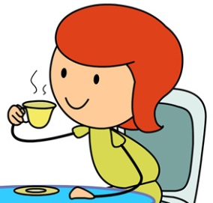
Tia: No, I’m not. I’m drinking tea.
Ne, ne čekam. Pijem čaj.


Ollie: Are you sitting at the table?
Sjediš li za stolom?

Tia: Yes, I am.
Da, sjedim.


Ollie: I know. You’re in a cafe. Right?
Znam gdje si. Ti si u kafiću. Jesam li u pravu?

Tia: Yes.
Da.

b) Listen to your teacher read the text once again.
What is Tia doing? Circle the correct sentences.
Be careful. There are more than one correct answer.
Poslušaj svog učitelja kako čita tekst još jednom. Što radi Tia?
Zaokruži točne odgovore. Budi pažljiv više odgovora je točno.

1 Tia is watching a play.
Tia gleda kazališnu predstavu.
2 Tia is watching a film.
Tia gleda film.
3 Tia is texting Paula..
Tia se dopisuje s Paulom.
4 Tia is waiting for a bus.
Tia čeka autobus.
5 Tia is drinking tea. 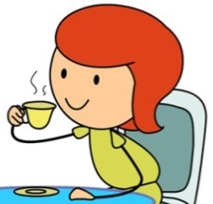
Tia pije čaj.
6 Tia is sitting at the table .
Tia sjedi za stolom.

c) Listen to your teacher read the text once again.
Where is Tia? Circle the correct sentence.
Poslušaj svog učitelja kako čita tekst još jednom. Gdje je Tia?
Zaokruži točan odgovor.
1 Tia is at the train station. 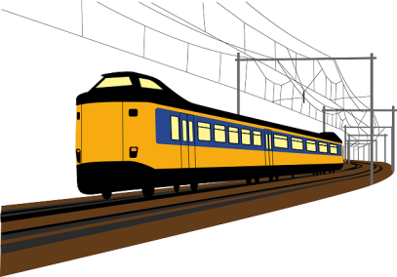
Tia je na željezničkoj stanici.
2 Tia is in a cafe.
Tia je u kafiću.
3 Tia is at the bus stop.
Tia je na autobusnoj stanici.

d) Look at the pictures.
Listen to your teacher read the words.
Pogledaj slike. Poslušaj učitelja kako čita riječi koje ih opisuju.

CAFE (kafić) TRAIN STATION (željeznička stanica)
BUS STATION (autobusna stanica)

- 2 a) Look at the people in the picture. What are they doing?
Talk to your classmate.
Pogledaj ljude na slici. Što rade? Razgovaraj s prijateljem iz razreda.

4 SUSAN
3 MR DARK
2 ELLA
1 TERRY

5 BILL
6 FIONA

7 MS WHITE

b) Listen to your teacher read the sentences.
Point to the character. Cricle what he / she is doing.
Poslušaj svog učitelja kako čita rečenice. Pokaži tog lika.
Zaokruži ono što on / ona radi.

1 Terry is playing the guitar.  Terry svira gitaru.  2 Ella is riding a bike.  Ella vozi bicikl.  3 Mr Dark is reading the  newspapers.  Gospodin Dark čita novine. | 4 Susan is taking a dog for a walk.  Susan vodi psa u šetnju.  5 Bill is waiting for a bus.  Bill čeka autobus.  6 Fiona is selling flowers.  Fiona prodaje cvijeće.  7 Ms White is eating and  ice-cream.  Gospođa White jede sladoled.

b) Match the beginnings to the endings of the sentences.
Find help in task 2 b).
Spoji početak rečenica s krajem rečenice.
Ako trebaš pomoć, pronađi ju u zadatku 2 b).
A ...is taking a dog for a walk.
vodi psa u šetnju.

B ...is riding a bike.
vozi bicikl

C ...is waiting for a bus.
čeka autobus.

D ...is selling flowers.
prodaje cvijeće.

E ...is playing the guitar.
svira gitaru.

F ...is eating and ice-cream.
jede sladoled.

G ...reading the newspapers.
čita novine.
1 Terry
…

2 Ella

3 Mr Dark

4 Susan

5 Bill

6 Fiona

7 Ms White

c) Answer the questions. Copy the sentences from task 2 c).
Odgovori na pitanja. Prepiši rečenice iz zadatka 2 c).
1 What is Terry doing?
_________________________________________________ .
2 What is Ella doing?
_________________________________________________ .
3 What is Mr Dark doing?
_________________________________________________ .
4 What is Susan doing?
_________________________________________________ .
5 What is Bill doing?
_________________________________________________ .
6 What is Fiona doing?
_________________________________________________ .
7 What is Ms White doing?
_________________________________________________ .
d) Ask your friend questions from task 2 d). Swap roles.
Pitaj svog prijatelja iz razreda pitanja iz zadatka 2 d).
Na kraju, zamijenite uloge – on neka tebe pita, a ti odgovaraj.

e) Play a guessing game. Can you guess the character?
Read the description and try to guess the who it is.
Use the picture in task 2 a).
Odigraj igru pogađanja. Pročitaj opis i pokušaj pogoditi tko je to.
Koristi se slikom u zadatku 2 a).

GUESS WHO 1
POGODI TKO 1
1 She is a woman. 
Ona je žena.
2 She has got dark hair. 
Ona ima tamnu kosu.
3 She is smiling.
Ona se smiješi.
4 She is selling flowers.
Ona prodaje cvijeće.

GUESS WHO 2
POGODI TKO 2

1 He is a boy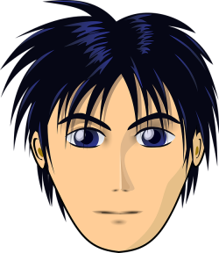.
On je dječak.
2 He has got long hair.
On ima dugu kosu.
3 He has got ginger hair .
On ima riđu (naranačastu) kosu.
4 He is playing the guitar.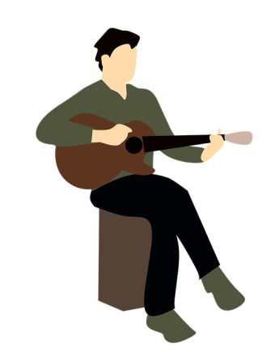.
On svira gitaru.

